**Final Report**

**Project: Implementation of LSM-Tree Based Key-Value Store**

Team: Jiangshan Luo, Ruidong Duan

1. **Introduction**

Our motivation is to get to know about how an LSM-tree store works and methodology underneath it, and also to improve our programming skill. We implemented a very basic LSM-tree key-value store that uses leveling and coded in C++. By doing so, we deeply understand lots of details in LSM-tree, its workflow, and some coding issues such as the implementation of a bloom filter, I/O, and data system configuration.

1. **Background**

Our system design is inspired by Monkey and the original LSM-tree store. We use techniques like bloom filter, vector, hash function and file I/O. The core technique of LSM-tree is to take advantage of continuous storage space to make system reading latency lower. There is a buffer in memory. When an entry is to be inserted, put it into the buffer, and flush it into disk if the buffer is full. In disk(s), as data growing larger, we merge and sort them into bigger runs, so we can use binary search to speedup lookups. Bloom filter is used to avoid wasting time in finding non-exist entries, where some hash functions are needed. We use vector to store buffer, bloom filters, and to move data blocks.

1. **Design**

**Architecture Design**

The system we implemented uses only leveling for better reading latency. This system includes basic components of an LSM-tree: a buffer, Bloom filters and fence pointers in main memory, and runs (data blocks) in secondary storage. There are mainly four classes which contain the needed data structures and APIs: buffer, BloomFilter, LSM, and DiskRun. The visualization of our design refers to Figure 1.

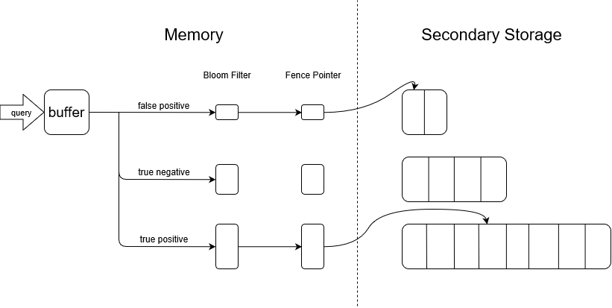

Figure 1. System Design

**API**

|  |  |
| --- | --- |
| **Classes** | |
| class **LSM**{  Buffer buffer[];  DiskRun* diskrun[];  BloomFilter* filter[];  LSM(int, int, int, int, float);  void insert(K, V);  vector range(K, K);  void delete_key(K);  Pair lookup(K);  }  class **buffer**{  vector buffer;  buffer(int);  void insert(Pair);  vector range(K, K);  Pair* lookup(K);  void push ();  } | class **bloom_filter**{  vector filter;  BloomFilter(int, double);  void addkey(K);  bool contain(K);  void clear();  }  class **DiskRun**{  string path;  K fencepointer[];  Pair* lookup(K);  vector rangeSearch(K, K);  void merge(vector);  }  Struct Pair{  K key;  V value;  } |

1. **Evaluation**

**Experimental Setup**

For experimentation, we use a machine with a 1TB SATA HDD, 8 GB DDR4 main memory, and six 2.20 GHz cores with 9 MB L3 Cache. The operating system we use is Windows 10 Home Edition where the experiment is run on an NTFS partition.

Default setting: size of an entry is 8B, size ratio is 2, page size is 4KB, and false positive rate is 0.1.

**Experimental Workloads**

There are several experiments that we will use to evaluate our system.

* We will test the system’s capability with increasing data volume. To do that, we will run the test multiple times with the same (default) system configuration, each time using more data entries.
* And also, we want to know how the entry size of our system could affect the overall performance. Using a similar set up as the first experiment, we keep the data volume constant this time, instead, we gradually increase the entry size for each test and evaluate the performance changes.
* Thirdly, we try to find out how the system handle tradeoff between update and lookup, by changing the ratio size from 2 to 16.
* The fourth aspect is to test the throughput performance under different workloads. In this case, we will use various workloads which are different in lookups/updates ratios.

Figure 2 Figure 3

Figure 4 Figure 5

From figure 2 and 3, we can see that as numbers of entries and entry size growing, look up latency does not obviously increase, which is probably as a result of using bloom filter and fence pointer appropriately. From figure 4, it is shown that by changing ratio size, we can do some tradeoffs between lookup and update latency. In figure 5 shows that ratio of lookups in workload will not seriously decrease throughput. These results help validate that our approach achieve its goal.

1. **Conclusion**

We implemented an LSM-tree key-value store, which can do basic operations update, delete, lookup, and range search. To do this, we research and build bloom filter, buffer, and runs in disks. Result of the evaluation well fits in with our expectation. From the evaluation, we show that our system is functional and has a decent performance. In conclusion, we achieved our goal, to research and build a functional LSM-tree store, and also to improve our programming skill.